SAMPLE LATE RETURN DISCLAIMER FORM INSTRUCTIONS
This form may be used to disclaim a Late Return claim made by adjustment only if the check was returned within the applicable required deadlines.

When Late Return Disclaimer Can be Made: This form is to be used by the Paying Bank with the Late Return Disclaimer to disclaim an invalid Late Return claim adjustment. Use of the Late Return Disclaimer is appropriate only when:
- the Depositary Bank made a Late Return claim adjustment; and
- the Paying Bank returned the item within applicable required deadlines (see below)
A Late Return Disclaimer should not be made if the item was returned after the Uniform Commercial Code (UCC) and/or Regulation CC (Reg CC) return deadlines.
Return Deadlines: The UCC requires the Paying Bank to pay or return the item by midnight of the banking day following the banking day of presentment (UCC 4-301, 4-302) and Regulation CC requires the Paying Bank to return the check “in an expeditious manner” (§ 229.31(b)) generally so that it will be received by the Depositary Bank by 2:00 p.m. (local time of Depositary Bank) on the second business day after the banking day of presentment. The return deadline timeclock begins on the banking day of presentment.
Under UCC 4-104(3), Banking day means the part of a day on which a bank is open to the public for carrying on substantially all of its banking functions; Under Regulation CC 229.2(f), Banking day means that part of any business day on which an office of a bank is open to the public for carrying on substantially all of its banking functions.
Under Regulation CC 229.2(g), Business day means a calendar day other than a Saturday or a Sunday, January 1, the third Monday in January, the third Monday in February, the last Monday in May, July 4, the first Monday in September, the second Monday in October, November 11, the fourth Thursday in November, or December 25. If January 1, July 4, November 11, or December 25 fall on a Sunday, the next Monday is not a business day.
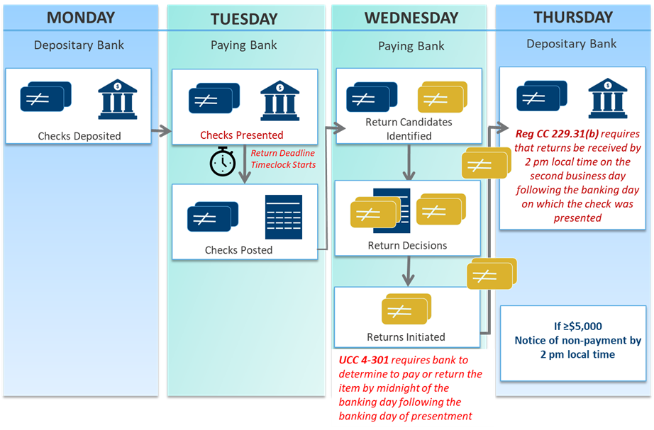

Fraudulent Items Must Be Returned within Required Return Deadlines: Counterfeit/forged/altered items must be returned within the UCC/Reg CC deadlines even if the customer notifies the Paying Bank about the fraud beyond the return deadlines. Although fraudulent items must be returned within return deadlines, there may be another remedy available to the Paying Bank regarding the fraudulent item (e.g., a direct warranty claim, etc.). In addition, the Paying Bank may have a legal defense to a Late Return claim made by adjustment (e.g., breach of presentment warranty under the UCC). However, such defenses should be handled outside of the adjustments process and not through use of a Late Return Disclaimer.
Each Paying Bank warrants in Reg CC 229.34(d) that it returns a check within the UCC midnight deadline and the Reg CC expeditious return requirements. Failing to return within these timeframes constitutes a breach of the return warranty, and the paying bank is liable to the depositary bank for the amount of the late return for up to one year from the cash letter date of the late return.
Regulation CC sets forth certain limited exceptions to the Reg CC expeditious return rule such as for: checks drawn on US Treasury, US Postal Service money orders, and checks drawn on a state or unit of general local government that is not payable at/through a bank (Reg CC 229.42); Depositary Banks that do not have arrangements in place to accept electronic returned checks directly or indirectly through commercially reasonable means (Reg CC 229.33(a)); Depositary Banks not subject to Reg CC Subpart B because for example they maintain only time and savings accounts or are not a depository institution (Reg CC 229.31(d)(1)); or the Paying Bank is unable to identify the Depositary Bank of the check (Reg CC 229.31(d)(2)).
Regulation CC also extends the UCC midnight deadline to the time of the Paying Bank’s dispatch of the return (if after the midnight deadline) where the Depositary Bank (or receiving bank if the Depositary Bank is unidentifiable) receives the return by the Depositary Bank’s (or receiving bank’s) cut-off hour on its next banking day. (Special rules are provided in the event the Paying Bank’s midnight deadline is on a Saturday which is a banking day for the Paying Bank.) Reg CC 229.30(g).
For more info on proper return of items, see ECCHO Rules Exhibit VII
Instructions for Making this Disclaimer: (Complete information on the form on the next page)
- This form should be reviewed by your bank’s legal counsel prior to use
- Provide information about the Late Return claim adjustment that was made against your bank
- Provide information on the presentment and return of the item in question
- Ensure that the item was returned within the applicable UCC and Reg CC deadlines
- Check the reason for disclaimer
- Sign and include contact information
- Include a copy of the item

Note: The Paying Bank may have a legal defense to a Late Return claim adjustment (e.g., breach of presentment warranty under the UCC). However, such defenses should be handled outside of the adjustments process and not through use of a Late Return Disclaimer.
SAMPLE LATE RETURN DISCLAIMER FORM
This form may be used with a Late Return Disclaimer. A Late Return Disclaimer may be made only if the item was returned within the applicable required deadlines.

Counterfeit/forged/altered items may not be returned after the UCC midnight deadline or Reg CC expeditious return deadline.

Date: INSERT DATE
Re: Late Return Disclaimer
Purpose: To disclaim a late return claim because the check was returned properly within UCC and Reg CC deadlines.
Disclaimer made to: INSERT BANK NAME / INSERT ABA ROUTING NUMBER
Your Bank Late Return Case/Reference Number: INSERT NUMBER
Disclaimer made by: INSERT OUR BANK NAME / INSERT OUR ABA ROUTING NUMBER
Our Bank Case/Reference Number: INSERT NUMBER
This letter constitutes our bank’s disclaimer and refusal of your bank’s Late Return claim adjustment.

Information on Presentment: We certify that this item was presented to us or our processor by:
Bank Name: INSERT BANK NAME / INSERT ABA ROUTING NUMBER
Received Date: INSERT DATE
Received Time: INSERT TIME
Cash Letter Date: INSERT DATE
Cash Letter Total: INSERT INFORMATION
Sequence Number: INSERT INFORMATION

Information on Return: We returned this item to:
Bank Name: INSERT BANK NAME / INSERT ABA ROUTING NUMBER
Return Cash Letter Date: INSERT DATE
Return Cash Letter Total: INSERT INFORMATION
Bundle (Tape) Total: INSERT INFORMATION
Sequence Number: INSERT INFORMATION
Listed between items INSERT INFORMATION and INSERT INFORMATION
Check Information/MICR Line:
External Processing Code:
ABA Routing Number:
Account Number:
Serial Number:
Amount:

Reason for Disclaimer:
☐ Our bank returned this item within required UCC and Regulation CC deadlines. (See information on pages 1 and 2 of the instructions.)
By checking this box, we certify that these deadlines were met.

A COPY OF THE ITEM HAS BEEN INCLUDED

INSERT SIGNATURE
INSERT PHONE NUMBER / EMAIL ADDRESS
By signing, we certify that the required UCC and Regulation CC return deadlines were met and that use of the Late Return Disclaimer is appropriate. A Paying Bank may only use the Late Return Disclaimer to disclaim a Late Return claim adjustment if it in fact returned the check within the applicable required UCC and Regulation CC return deadlines.

Return Deadlines: return deadlines include the UCC requirement for the paying bank to either pay or return the item by midnight of the banking day following the banking day of presentment (UCC 4-301, 4-302) and the Regulation CC requirement for the paying bank to return the check “in an expeditious manner” (§ 229.31(b)) generally so that it will be received by the depositary bank by 2:00 p.m. (local time of depositary bank) on the second business day after the banking day of presentment. The return deadline timeclock begins on the banking day of presentment. Regulation CC sets forth certain limited exceptions to the expeditious return rule and UCC midnight deadline. Please see ECCHO Rules Exhibit VII for more information.
Note: Your bank may have a legal defense to a Late Return claim adjustment (e.g., breach of presentment warranty under the UCC). However, such defenses should be handled outside of the adjustments process and not through use of a Late Return Disclaimer.

